I did not actually do a tutorial for MATLAB because I know someone who used to use MATLAB for their electrical engineering degree. I worked on the project instead, starting with the plotting program. I used a forum for MATLAB to figure out the code needed to export the x and y values into a csv file and how to read them from that csv file for the part of the program that required salting the data. So, my starting point was just graphing and printing out on to a csv the x and y points. Below is a screenshot of the code for the plotting program in MATLAB and the graph of those equations:

Moving forward I took the csv that was created for each of these graphs and imported them into the salting part of the program. I do not have a screenshot of the code for the salting program, but from there I added noise to both the x and y values from the csv files. Below is a picture of the graphs with noise added to the x and y values:

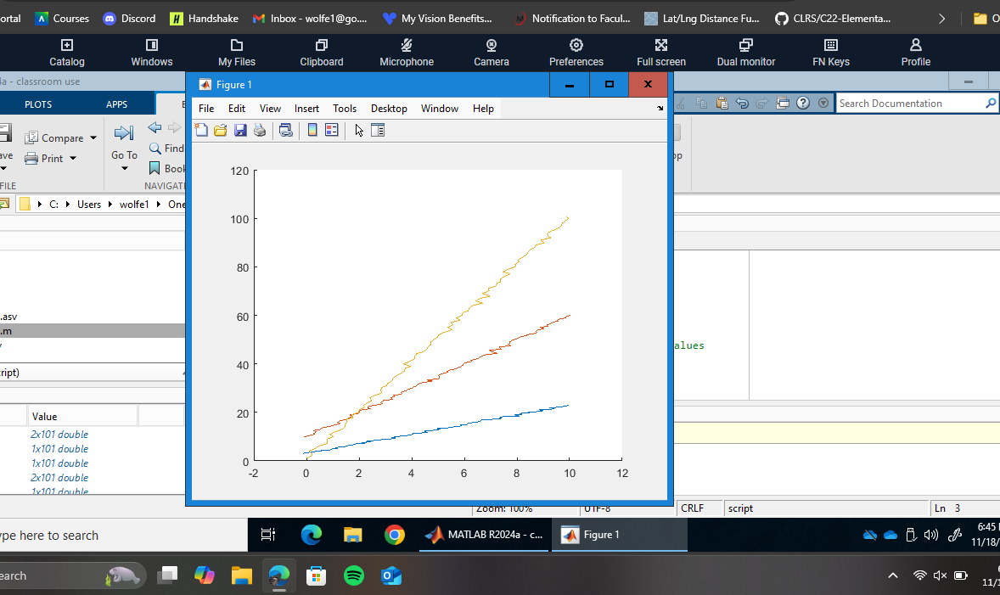

From this point trying to get those x and y values into another csv file was not working and nothing from the forum was helping me figure out how I could achieve what was being asked. So I took the code that added noise to the x and y values of the graphs and put them into the smoothing program. From there I used the smoothing function to smooth out the x and y values which produced the following image. A computer screen with a graph on it

Now the graphs from the smoothing program aren’t the same as the original graph. It’s as close to the original as I can get from salting the x and y values.